 Rob & Debbie Rivett

At Mundford Village Hall on Sunday 22nd February 2026

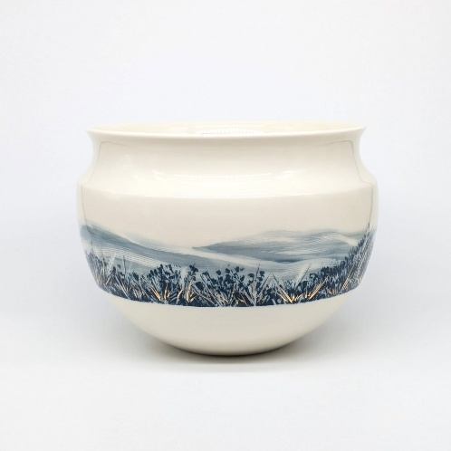
  10am  10:30am  12:45pm  1:45pm  4pm | Tea/coffee  Rob & Debbie Demo  Lunch  Rob & Debbie Demo  Demonstration finish

Working together, Rob throws and Debbie decorates, they create modern porcelain pieces inspired by nature and organic forms. These are decorated with beautiful, coloured slips that combine painting and scraffito techniques.
Website: https://www.robanddebbierivett.co.uk/
Instagram: https://www.instagram.com/robanddebbierivett/
Facebook: https://www.facebook.com/cellarceramics

Display of members work: We would like to see examples of your current work. It’s always nice to see what people are making.
‘Exchange and Mart’: There will be tables for small items for sale or exchange.
Lunch: To take part in the Pot Luck lunch, please bring a plate of food to share, either savoury, salad or cake, placing it on the table when you arrive. Cold food only please. Alternatively bring your own lunch. Don’t forget to bring a mug! We still need volunteers to take cling film etc. off shortly before lunch and set up the urns and cups for tea and coffee (so people can help themselves). Cakes will be served at lunchtime, to avoid crumbs later in the day. We also need volunteers to help set up from 9am and pack away at the end of the day.
Queries about lunches: please contact Rose at rose.brettingham.ceramics@gmail.com
Directions: Mundford is at the junction of the A134 and A1065, north of Thetford. Village Hall - IP26 5DW

Please send to: Rose Brettingham, 9 Trory Street, Norwich, NR2 2RH
Tel: 07788 187883 or rose.brettingham.ceramics@gmail.com
Anglian Potters event: Rob & Debbie Rivett, 22nd February 2026
Members: £12 Non members: £15
Member’s name (please print): ________________________________ Tel: __________________

Guest's name (please print): __________________________________ Tel: __________________

