 | Janene Waudby  At Mundford Village Hall on Sunday 2nd November 2025
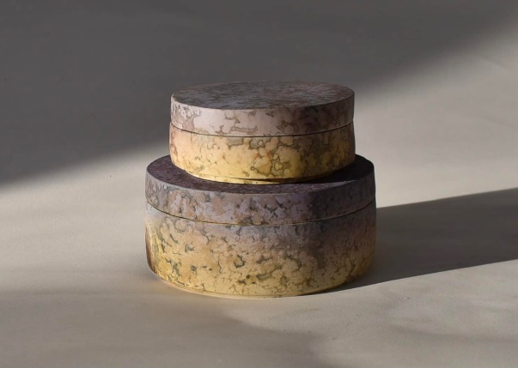
  10am  10:30am  12:45pm  1:45pm  4pm | Tea/coffee  Janene  Lunch  Janene  Demonstration finish

Janene has had a lifetime’s interest in the sea and nature, walking, diving and sailing all over the world, including a half circumnavigation around Cape Horn and across the Southern Ocean. She finally left her desk job in 2015 and became a full time artist, initially living in the Scottish Highlands. She now lives and work in rural East Suffolk where the landscape continues to inspire her work.

Her vessels are often curved in form, carrying a simplicity and relationship to nature itself. Her work can be variously thrown on the wheel, coiled or slab built. As the vessels dry, smooth surfaces are burnished with a stone to a soft sheen, whereas textured surfaces are created with complex layers of slip, engobe and oxides. Surfaces are left unglazed, exposing the raw clay surfaces.

www.jwaudbyceramics.com

Display of members work: We would like to see your work from this year’s Potters Camp as well as examples of your current work. It’s always nice to see what people are making.

‘Exchange and Mart’: There will be tables for small items for sale or exchange.

Lunch: We have re introduced pot luck lunch. Please bring a plate of food to share, either savoury, salad or cake, put your contribution on the table when you arrive. Cold food only please. Alternatively bring your own. Don’t forget to bring your own mug! We still need volunteers to take the cling film etc. off shortly before lunch and to set up the urns and cups for tea and coffee (so people can help themselves). Cakes will be served at lunchtime, to avoid crumbs later in the day! We also need volunteers to help set up from 9am and pack away at the end of the day.

Queries about lunches, please contact Rose at rose.brettingham.ceramics@gmail.com
Directions - Mundford is at the junction of the A134 and A1065, north of Thetford. Village Hall - IP26 5DW

Please send to: Rose Brettingham, 9 Trory Street, Norwich, NR2 2RH
Tel: 07788 187883 or rose.brettingham.ceramics@gmail.com

Anglian Potters event: Janene Waudby, Sunday 2nd November 2025 Member £12, Non member £15

Member’s name (please print) _________________________________ Tel _____________

Guest's name (please print) ___________________________________ Tel _____________

