 | Louise Bell  At Mundford Village Hall on Sunday 6th April 2025
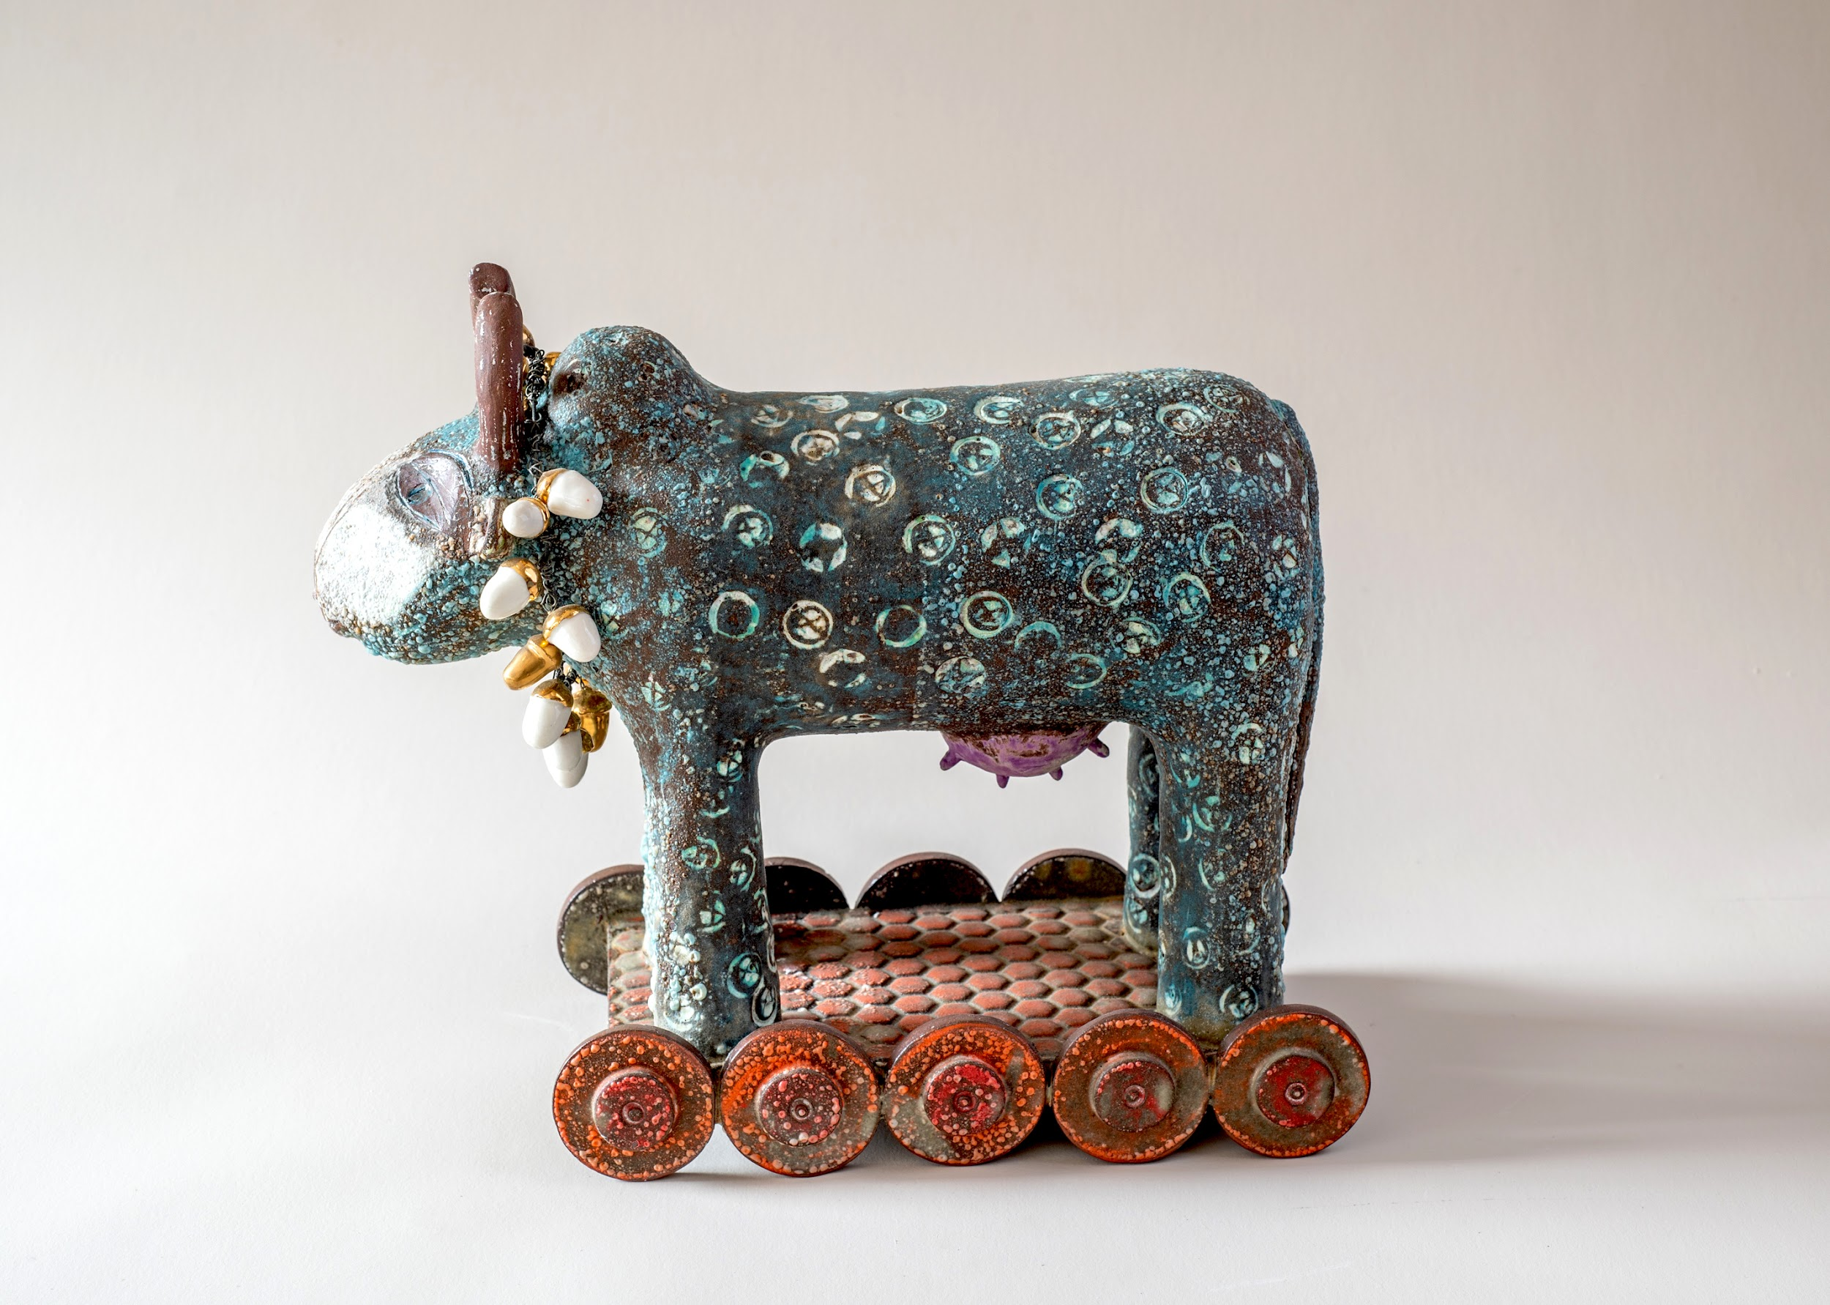 | 10am 10:30am 12:45pm 1:45pm 4pm Tea/coffee Louise Lunch Louise Demonstration finish

After working in education for many years, Louise completed a Masters in Craft at Brighton University in 2017. Her work is project based, exploring themes or questions related to story telling and communicating ideas. Each unique piece is hand built, with lots of idea development and research, creating lots of drawings and experiments. Louise uses different handbuilding methods, slabs and press-moulds, and makes her own stamps to create textures. She adjusts glazes to suit each piece, which is then fired four times, the last firing being gold lustre and decals.

There will be a hands-on element to this demonstration, so bring something hard (book/cardboard) to lean on your lap, and wear suitable clothing!

www.louisebellceramics.com

Display of members work: We would like to see examples of your work from this year’s Potters Camp; the good, the bad and the ugly! Also bring examples of your work. It’s always nice to see what people are making. ‘Exchange and Mart’: There will be tables for small items for sale or exchange.

Lunch: We have re introduced pot luck lunch. Please bring a plate of food to share, either savoury, salad or cake, put your contribution on the table when you arrive. Cold food only please. Alternatively bring your own. Don’t forget to bring your own mug! We still need volunteers to take the cling film etc. off shortly before lunch and to set up the urns and cups for tea and coffee (so people can help themselves). Cakes will be served at lunchtime, to avoid crumbs later in the day! We also need volunteers to help set up from 9am and pack away at the end of the day.

Queries about lunches, please contact Rose at rose.brettingham.ceramics@gmail.com
Directions - Mundford is at the junction of the A134 and A1065, north of Thetford. Village Hall - IP26 5DW

Please send to: Rose Brettingham, 9 Trory Street, Norwich, NR2 2RH
Tel: 07788 187883 or rose.brettingham.ceramics@gmail.com

Anglian Potters event: Louise Bell, Sunday 6th April 2025 Member £12, Non member £15

Member’s name (please print) ------------------------------------------------------ Tel -----------------

Guest's name (please print) --------------------------------------------------------- Tel -----------------

