 | Daniel Boyle  At Mundford Village Hall on Sunday 2nd March 2025
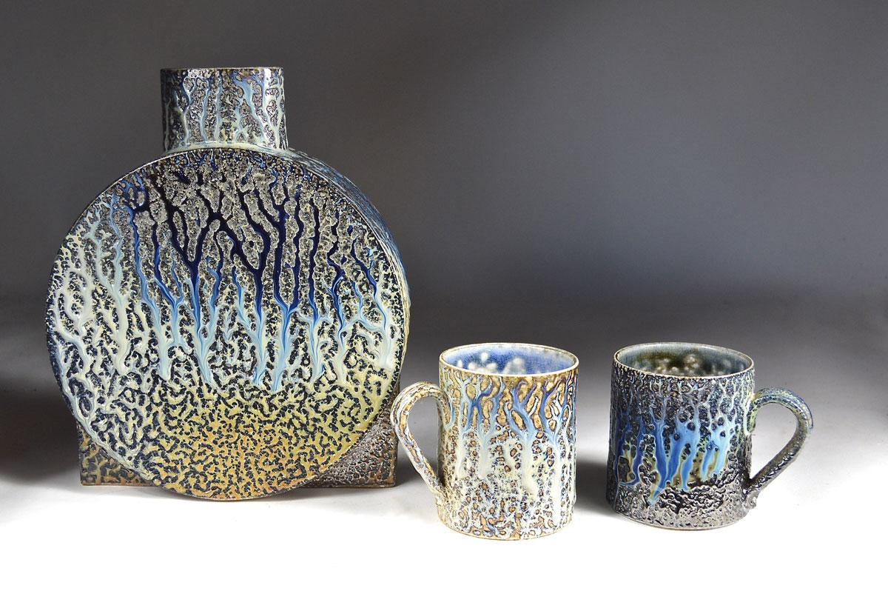 | 10am – tea/coffee  10:30am – Danny  12:45pm - lunch  1:45pm – Danny  4pm – demonstration finish

Daniel studied ceramics at Harrow before moving to Wales where he continues to make his individual thrown functional work, decorated with a combination of slips and ash glazes, which he then salt fires to encourage unique highly textured surface qualities full of life and movement. www.danielboyleceramics.com

Display of members work: We would like to see examples of your work from this year’s Potters Camp; the good, the bad and the ugly! Also bring examples of your work. It’s always nice to see what people are making. ‘Exchange and Mart’: There will be tables for small items for sale or exchange.

Lunch: We have re introduced pot luck lunch. Please bring a plate of food to share, either savoury, salad or cake, put your contribution on the table when you arrive. Cold food only please. Alternatively bring your own. Don’t forget to bring your own mug! We still need volunteers to take the cling film etc. off shortly before lunch and to set up the urns and cups for tea and coffee (so people can help themselves). Cakes will be served at lunchtime, to avoid crumbs later in the day! We also need volunteers to help set up from 9am and pack away at the end of the day.

Queries about lunches, please contact Rose at rose.brettingham.ceramics@gmail.com
Directions - Mundford is at the junction of the A134 and A1065, north of Thetford. Village Hall - IP26 5DW

Please send to: Rose Brettingham, 9 Trory Street, Norwich, NR2 2RH
Tel: 07788 187883 or rose.brettingham.ceramics@gmail.com

Anglian Potters event: Daniel Boyle Sunday 2nd March 2025 Member £12, Non member £15

Member’s name (please print) ------------------------------------------------------ Tel -----------------

Guest's name (please print) --------------------------------------------------------- Tel -----------------

