 | Paul Smith  At Mundford Village Hall on Sunday 3rd November 2024

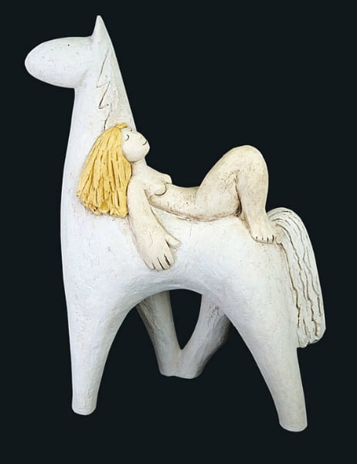 | 10 am – tea/coffee  10:30am – Paul Smith  12:45pm - lunch  1:45pm – Paul Smith  4.00pm – demonstration finish  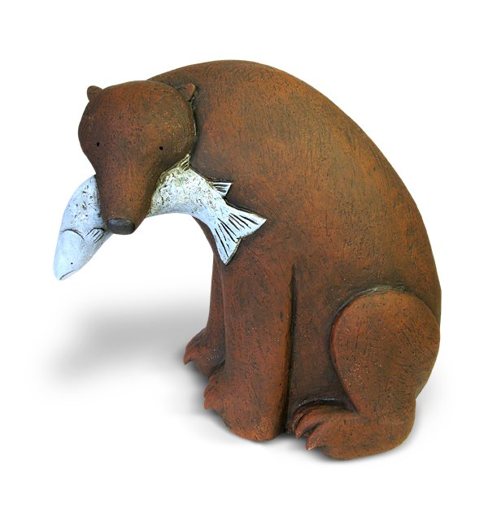
Paul makes figurative sculptures, dream-like and contemplative in their composition, creating a feeling of another reality where there is a peaceful co-existence between us and nature. Inspiration comes from fairytales and fables, but turning them upside down, such as Goldilocks making peace with the three bears.
He uses an unconventional hand-building method to create his bold and semi-abstract style with sweeping curves and simplified details. Influenced by Ian Gregory’s working method, Paul uses metal rods to support the structure while making. A combination of slips, oxides, stains and underglazes are used when decorating.
This demonstration will include the opportunity for some hands-on play, so bring a hand towel/apron/messy clothes!

Display of members work: We would like to see examples of your work from this year’s Potters Camp; the good, the bad and the ugly! Also bring examples of your work. It’s always nice to see what people are making.
‘Exchange and Mart’: there will be tables for small items for sale or exchange
Lunch:. We have re-introduced pot luck lunch. Please bring a plate of food to share, either savoury, salad or cake, put your contribution on the table when you arrive. Cold food only please. Alternatively bring your own. Don’t forget to bring your own mug! We still need volunteers to take the cling film etc. off shortly before lunch and to set up the urns and cups for tea and coffee (so people can help themselves). Cakes will be served at lunchtime, to avoid crumbs later in the day! We also need volunteers to help set up from 9am and pack away at the end of the day.

Queries about lunches, please contact Trudy at email rose.brettingham.ceramics@gmail.com
Directions: Mundford is at the junction of the A134 and A1065, north of Thetford. Village Hall postcode: IP26 5DW

Please send to: Rose Brettingham, 9 Trory Street, Norwich, NR2 2RH
Tel: 07788187883 or rose.brettingham.ceramics@gmail.com

Anglian Potters event: Paul Smith, Sunday 3rd November 2024 Members £12 Non members £15

Member’s name (please print) ----------------------------------------------------- Tel ------------------

Guest's name (please print) --------------------------------------------------------- Tel ------------------

